CIRCUIT ANALYSIS LAB_7
Name: Muhammad Uzair
Reg No: 2025-CE-112
Date: 3rdMay,2026

Experiment # 1:
Circuit Made In Proteus: Inverting OP-Amp
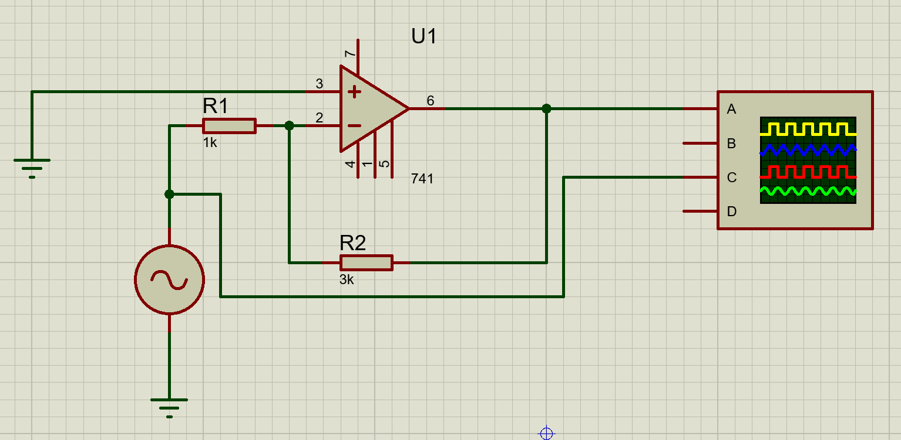
Construction:
- Insert an Op-Amplifier 741.
- Connect +ve terminal of the OP-Amp with ground.
- Connect a Resistor (R1) of 1kΩ with -ve terminal of Amplifier and other terminal of resistor with an alternator of 2V P-P and 40Hz frequency.
- Connect alternator with ground.
- Insert another resistor of 3kΩ and connect it’s one terminal in between R1 and OP Amp, connect other terminal with the output terminal of the OP Amp.
- Insert an Oscillator and connect terminal A with output of OP-Amp and terminal C in between alternator and R1.
- Run and Observe the waves on oscilloscope.

Experiment # 2:
Circuit Made In Proteus: Non-Inverting OP-Amp
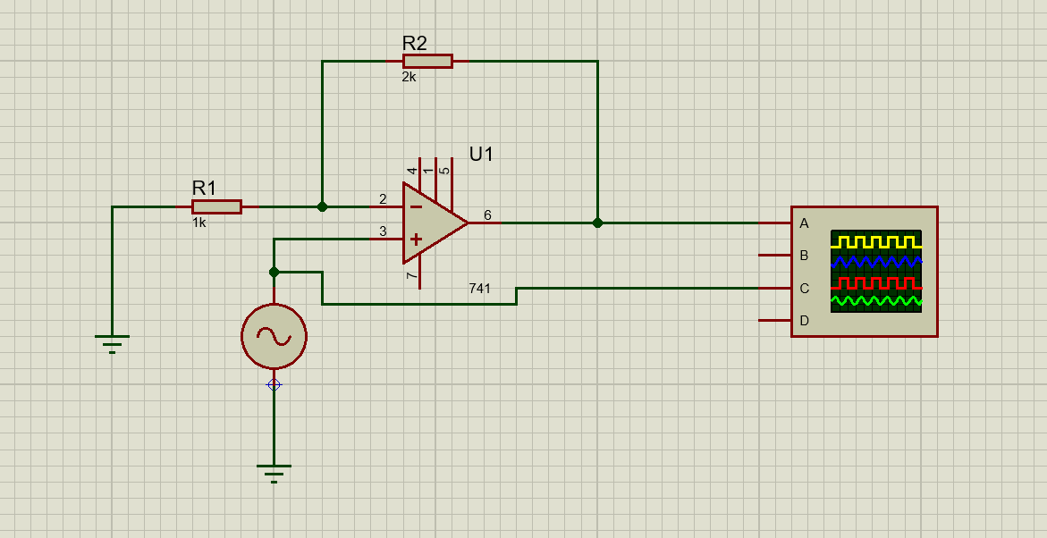
Construction:
- Insert an Op-Amplifier 741.
- Connect +ve terminal of the OP-Amp with an alternator of 2V P-P and 40Hz frequency and then with ground.
- Connect a Resistor (R1) of 1kΩ with -ve terminal of Amplifier and other terminal of resistor with ground.
- Insert another resistor of 2kΩ and connect it’s one terminal in between R1 and OP Amp, connect other terminal with the output terminal of the OP Amp.
- Insert an Oscillator and connect terminal A with output of OP-Amp and terminal C in between alternator and OP Amp.
- Run and Observe the waves on oscilloscope.

